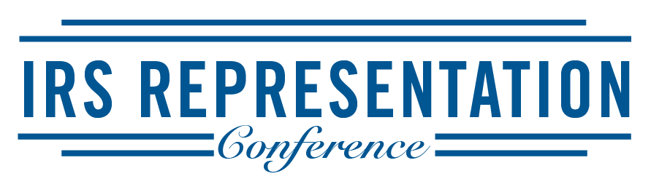
Registration Form – 2021 Conference

Name:________________________________________________
Firm:______________________________________________________
Email:______________________________________________________
Billing Address:__________________________________________________
Billing City/State/Zip:_______________________________________________
Telephone: _________________________ PTIN for CPE:_____________________________
Registration Rate
 $50 Thursday LITC Workshop (11/18) In-Person _____ Webcast _____  $249 $179 Conference Rate (11/19) In-Person _____ Webcast _____
❑ $299 $199 for Both Days In-Person _____ Webcast _____
Total Charge $_________
PAYMENT METHOD

 VISA  MASTERCARD  AMEX

Card Number:________________________________________ Exp. Date:_____________

Print Name on Card:___________________________________ CVV:__________________

Signature:___________________________________________ Billing Zip:______________
To Register:
Complete this form with your payment information and register by:
Mail: Green & Sklarz LLC, Attn: NE IRS Rep Conference, One Audubon St, 3rd Fl, New Haven, CT 06511
Fax: Attn: NE IRS Representation Conference, 203-286-1311
Email: Print and scan a copy of the form to registration@irsrepconference.com
Refund Policy: Due to limited seating, refunds will not be given after November 1, 2021.
Conference Dates: November 18 & 19, 2021

